Karnataka Valuation & E-Registration (KAVERI - 2.0)
Government of Karnataka

Functional Requirement Specifications

For KAVERI 2.0
Department of Stamps & Registration
Government of Karnataka

Digital e-Stamping for
optionally registerable Documents

Prepared by
Centre for Smart Governance (CSG)
2nd Floor, TTMC Yeshwanthapura, BMTC Bus station
Bangalore – 560022

Contents
1. Kaveri 2.0 4
2. Context of digital e-Stamp 4
3. User Management 5
4. Functional Requirements for Digital E-Stamp 6
4.1 Process flow for Document Generation 6
5. Verify Document 13
6. Assumptions 13
7. Reports and Dashboards 13
Annexures 14
Annexure 1: Optionally Registrable Articles 14
Annexure 2: Property Mapping 19
Annexure 3: List of sub-articles with relaxed validations
(E-aasthi, E-Swathu and ULMS) 27
Annexure 4: Minimum Party 29
Annexure 5: Witness Required or Not 37
Table of articles where witness is not mandatory 37
Table of Articles where witness is mandatory 39
Annexure 6: List of Article and Sub-Articles (Government Restrictions) 47
Annexure 7: Verify Document 48
Annexure 8: e-Stamp certificate template 49

Acronyms

CSG | Centre for Smart Governance
GL | Government Land
GR | Government Restriction
OTP | One-Time Password

Revision History

Date | Version | Prepared by | Reviewed by | Description
04-09-2025 | 1.0 | Yash Veer | Rajesh Hanbal  Principal Consultant | First Version

Kaveri 2.0
The Department of Stamps and Registration (hereinafter referred to as the “Department”) is entrusted with the custody, maintenance, and preservation of registered public records, including but not limited to the registration of marriages and firms, documents evidencing transactions such as sale, transfer, or gift of immovable properties, mortgages, powers of attorney, wills, and other instruments of legal or commercial significance. The Department, in addition to its custodial functions, is responsible for the levy and collection of stamp duty on behalf of the Government for transactions and instruments as prescribed under law. These services are administered through 258 Sub-Registrar Offices (SROs), operating under the supervision of 35 District Registrar Offices across the State.
Within this framework of Kaveri 2.0, optionally registrable articles occupy a distinct position under the Karnataka Stamp Act. These are instruments on which stamp duty is payable, though their registration under the Registration Act, 1908 is not compulsory. Such articles include documents relating to immovable property, movable property instruments, wills, powers of attorney, adoption deeds, bonds, affidavits, and diverse commercial agreements. While the payment of stamp duty is essential to validate such documents, parties retain the discretion to seek or forego registration, weighing the benefits of creating a public record and securing evidentiary value against the additional formalities of registration.

Context of digital e-Stamp
Currently, stamp duty for optionally registerable articles in Karnataka is collected primarily offline through the sale of non-judicial stamp paper and franking at authorised centres. Parties can purchase physical stamp paper from licensed stamp vendors, cooperative banks, treasury offices, or sub-registrar offices by paying the required denomination in cash or online. Alternatively, documents may be franked using mechanical impression machines at registration offices or designated franking centres, where duty is paid in cash/online and a numbered frank is affixed to the instrument. Receipts are issued on payment, and parties manually affix or incorporate the stamped or franked papers into their documentation for legal validation.
This document describes the functional features of the digital e-Stamp in Kaveri 2.0. Citizens can now apply for and obtain a digital e-Stamp for optionally registrable documents through Kaveri 2.0. It calculates stamp duty based on the property's value, type, and location, as provided by the user, and allows payments via UPI, net banking, or cards. Upon payment, a unique e-Stamp certificate is generated instantly, and citizens can download the digitally signed e-Stamp document from the dashboard. This ensures faster processing and transparency. The system streamlines workflows while reducing dependency on physical stamp vendors.

User Management
      - Digital e-Stamp (and Kaveri 2.0) to have Mobile OTP-based login along with the existing system of email-based login.
      - Every user (new and existing) must do Aadhaar-based e-KYC.
      - Email-based users and mobile-based users will have an option to link their email with their mobile and vice versa.

Functional Requirements for Digital E-Stamp

4.1 Process flow for Document Generation
4. The process flow for generating an E-Stamp after user login until completion of the digital e-Stamp is as follows:

Article Selection
5. Article-mapping will be two-level instead of the existing three-level.
The existing article mapping of document registration is three-level, i.e.
- The nature of the document is mapped to multiple Stamp articles.
- Each Stamp article is mapped to multiple sub-articles.
All the sub-articles of all stamp articles mapped to a nature document are currently shown. Instead, the revised article mapping must be two-level, i.e.
- Nature of document and Stamp Sub-article.

6. Only optionally registrable articles must be allowed as per annexure 1. Mandatorily registrable articles must not be available for selection.

7. Unlike document registration, where multiple sub-articles are allowed within a stamp article, only one sub-article selection per document is allowed.

Schedule Selection
8. There shall be an article to property register mapping based on the nature of the sub-article as per Annexure 2. Accordingly,
- Agricultural
- Non-Agricultural
- Miscellaneous (for articles without immovable property)

9. The Kaveri village and road must be asked only if market valuation is required for the article. The market valuation is currently only required for Joint Development Agreements.

10. The system should check for the following restrictions on agricultural property and allow the user to select the articles based on the restrictions as per Annexure 6:
- Do not allow any transaction on properties marked as GL.
- Do not allow any transactions on properties marked as GR.
- Only the full extent can be transacted if the agricultural property is alienated.

11. Validation at the source will be as is: The system does not allow properties to be fetched where property tax is not paid or if the properties are under mutation.

12. Validations for non-agricultural properties fetched from the property records (E-Aasthi /E-Swathu/ ULMS) to be relaxed for specific article as per annexure 3. Relaxed field to be:
- Fetched Owner Name Validation
- Extent Validation
- Boundary validation

13. A description of the schedule should be auto-generated for all documents containing immovable properties.

14. Since boundary information is not available with Bhoomi, it will only be input by the user, following which the schedule description will be auto-generated.

15. There will be no schedule description required for movable property articles.

Party Details
16. Imported parties: The executants for immovable properties will be fetched from the property registers.

17. Each party must provide their mobile number, and the system will authenticate them via OTP.

18. The fields concerning imported parties (details which are imported from property registers) are not editable except for a few articles which are having the relaxation as per Annexure 3.

19. The minimum number of parties is as per Annexure 4:
- For instance, for miscellaneous articles like a will or an affidavit, it is 1.
- However, in most of the articles dealing with immovable properties, it is 2, with at least one executant and one claimant.
20. Other party types: A combination of the following parties is allowed, leading to 9 scenarios, refer to Figure 1 and Table 01.
- Power of Authority
- Minor Guardian
- Organisation represented by a representative.
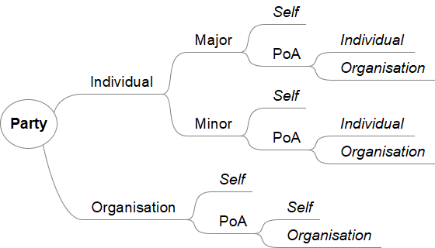

Figure 1: Mind Map of Party Type

Party Types | Is Minor? | Represent by | Is Org? | Outcome | Example
Individual | Major | Self | Individual | Individual party | Ramesh
Individual | Minor | Self | Individual | An individual party with a minor guardian | Ramesh is the minor guardian of master Amit
Individual | Minor | POA | Individual | The individual is represented by a minor guardian whose POA | Ramesh is the minor guardian of master Amit, whose POA is Pratap
Individual | Major | POA | Individual | The individual party is represented by the POA holder | POA Ashok represents Ramesh
Individual | Major | POA | Organization | The individual party is represented by a POA holder whose POA is an organisation. | Ramesh is the POA of Pratap, whose POA is ABC PVT LTD, represented by authorised signatory Ashwini
Individual | Minor | POA | Organization | The individual party is represented by a minor guardian whose POA is the organisation represented by an authorised signatory. | Ramesh is the minor guardian of master Pratap, who is represented by ABC PVT LTD, represented by authorised signatory Ashok.
Organization | NA | Self | Individual | Organisation is represented by an authorised signatory. | ABC PVT LTD is represented by authorised signatory Ramesh.
Organization | Major | POA | Individual | The organisation is represented by an authorised signatory whose POA is | An authorised signatory represents ABC PVT LTD, Ramesh, whose POA is Ram
Organization | Major | POA | Organization | The organisation is represented by an authorised signatory whose POA is the organisation. | ABC PVT LTD is represented by authorised signatory Ramesh, whose POA is XYZ PVT LTD, which is represented by authorised signatory Ram
Table 1: Party Type Scenarios

21. Proof of Identity: System accepts Aadhaar as a primary method of proof of identity.
- Aadhaar: Aadhaar is the primary proof of identification in Kaveri 2.0, and it’ll be validated using OTP.
- The party name and other details available with Aadhaar are auto-populated and not editable.
- Only for the fetched parties, there will be two names. The name fetched from the property register will be the primary name. Along with this, name as per Aadhaar will also be saved and displayed.
- The following details must be auto-populated:
- Name (First Name, Middle Name and Last Name)
- Age in Years.
- Gender (Male/Female)
- There should be an option to key in the details which are not populated during E-KYC.
- Relationship (S/O, D/O, W/O, C/O etc).
- Relative Name (text field having a max length of 50 characters).

22. Name matching will be enforced for fetched parties (Executant) only, and it will not be implemented for Organisations or organisational POAs/Authorised signatories.

23. Name matching will not be necessary in cases where names can be edited.
24. The name-matching functionality operates using the C-DAC algorithm with a configurable 80% similarity threshold. When the similarity score falls below 80%, the system displays a warning message to inform users about the name mismatch. Names are compared between data populated via UIDAI and property registers, including e-aasthi, e-Swathu, ULMS, Bhoomi.
25. For overseas users, an option will be provided to use the passport as a POI. If the user doesn’t have the Aadhaar to continue with the e-KYC flow, then the user can continue with the non-e-KYC flow with a passport or enrolment ID.
26. In the non-e-KYC flow, the system will prompt the user to finish the DSC before moving forward. The non-e-KYC flow is mentioned below:
27. Non-e-KYC Flow will be as follows:
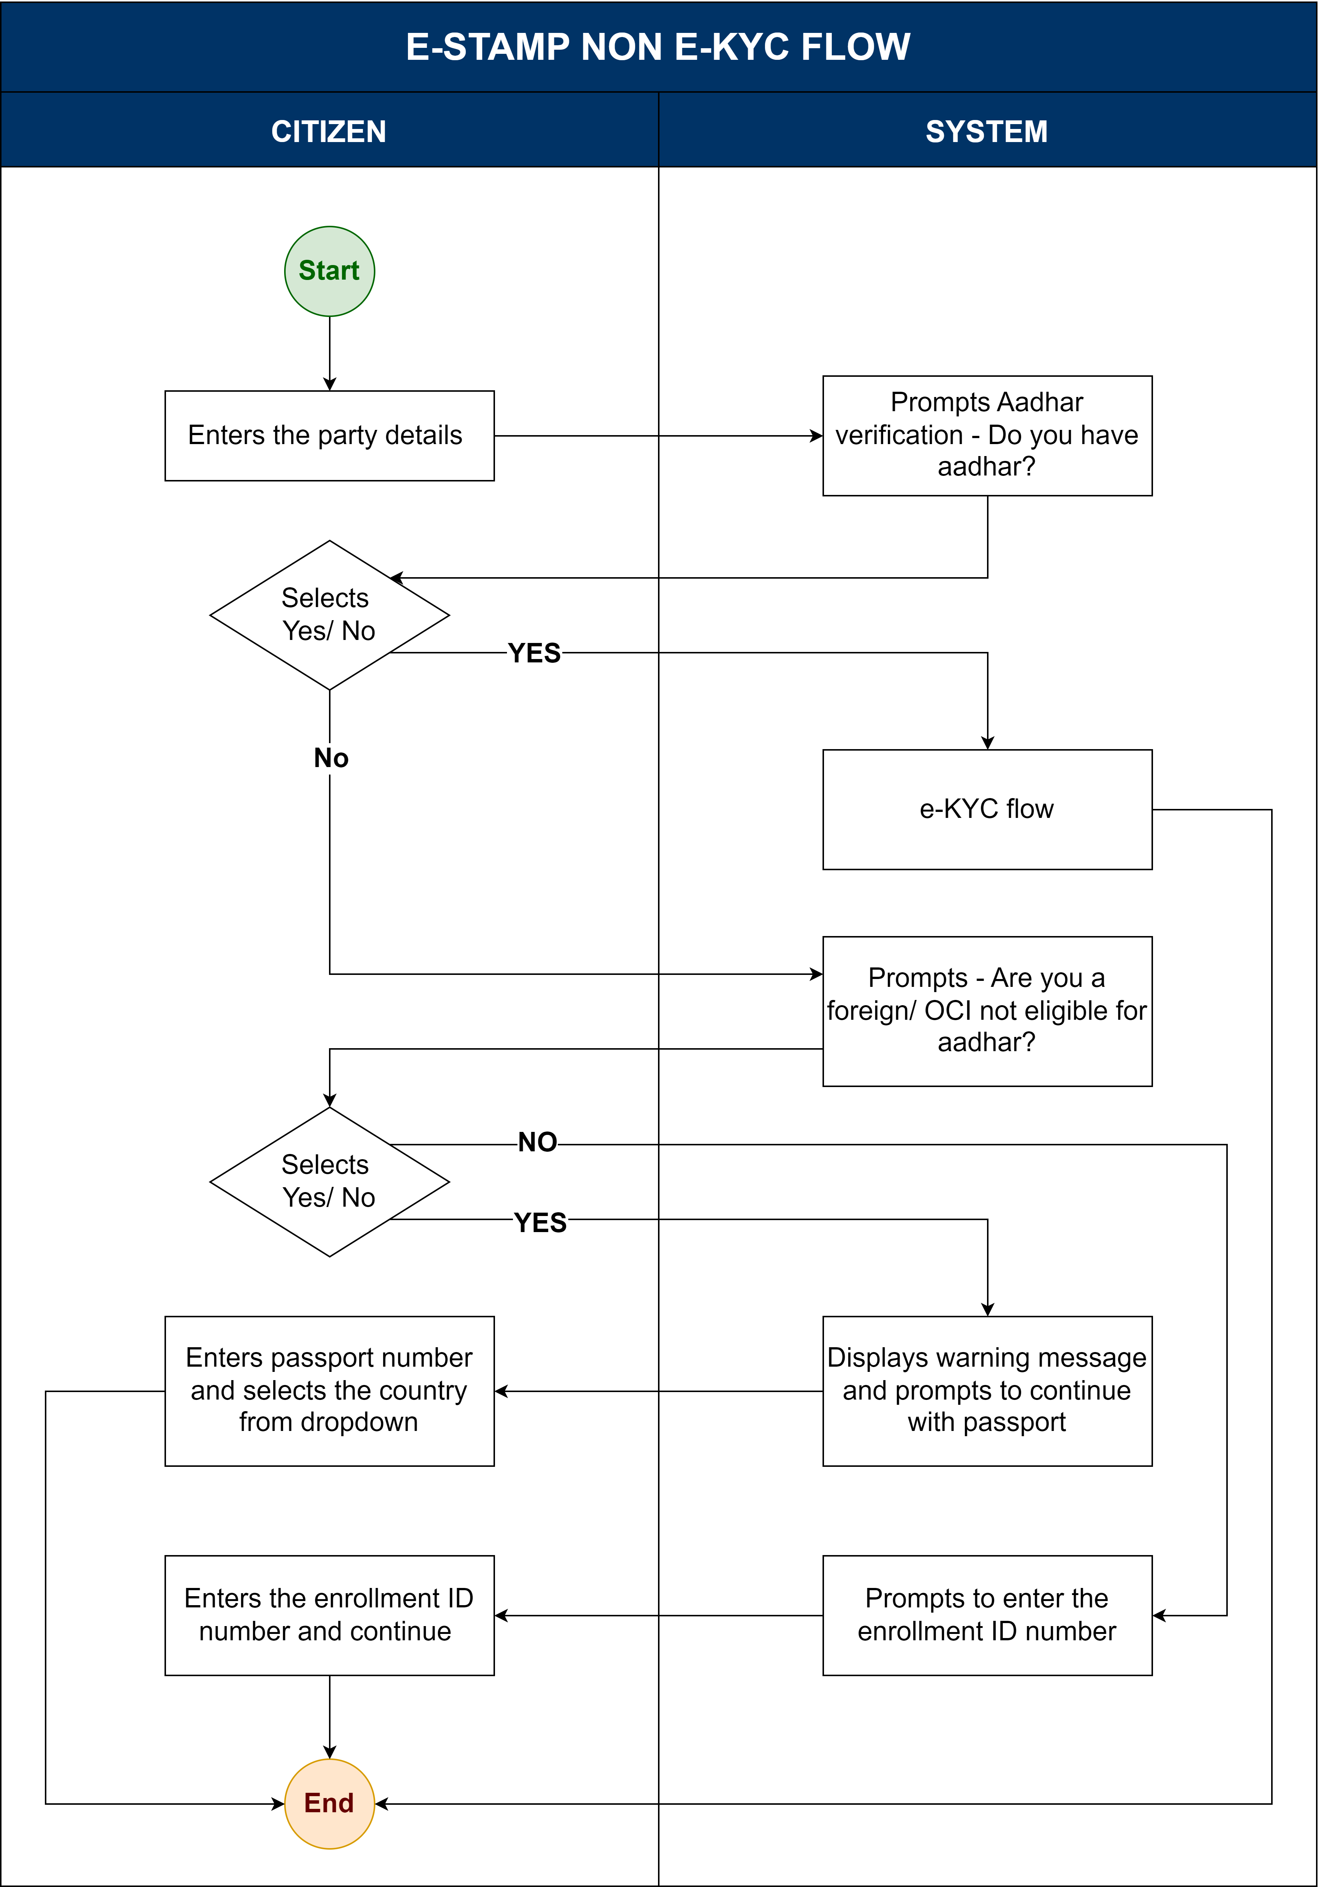

28. Witness details: Addition of a witness is based on the article selection as per Annexure 5. If the user selects the article that requires adding a witness after entering all the details of the parties, the user can continue adding witness details.
- The witness details will follow the same logic used for the claimant.
- The user details must be auto-populated upon doing E-KYC.
- There should be an option to validate the witness's Mobile Number (a Numeric field having a max length of 10 digits) using the OTP.
- In case a witness is mandatory or when the applicant chooses to add a witness when optional, a minimum of two witnesses is required.

29. Schedule allocation will map the property with the party (claimant) in case of transactions related to immovable property. Further, the allocation will happen as follows:
- Automatic allocation: In the case of a single claimant or a single schedule, the schedule must be allocated to the claimant.
- Manual allocation: In case of multiple schedules and multiple claimants, the system must allow the user to select and allocate the schedule manually.
- There will not be any schedule allocation for movable properties.

Fee calculations
30. The fee for an e-Stamp article shall be calculated based on the existing logic for document registration, specifically mapped to pre-defined e-Stamp articles. The calculation logic for each article is determined by one of four parameters:
- Market Valuation:
The fee is based on the current market value of the asset or property to which the document pertains.
- Consideration Value:
The fee is calculated based on the consideration (the amount agreed to be paid or transferred), as specified in the document.
- Fixed Stamp Duty:
The fee is a fixed value, predefined for the article, regardless of market or consideration value.
- Highest of All:
The fee is determined as the highest value among the applicable calculated fees (such as consideration)
31. The system shall recognise that, for optionally registrable articles:
- Minimum and maximum stamp duty shall not be applicable on 69 optionally registerable articles.
- Minimum and maximum stamp duty shall be applicable on 102 optionally registerable articles.

Preview and Fee payment
32. The system has to generate the draft e-Stamp document upon the user entering the details and description in the text box to generate the PDF.

35. The document will contain required metadata like certificate number, execute/claimant details, issue date, stamp duty amount, challan number, and description of document.

36. The document will have the QR code, which can be used to verify the authenticity of the e-Stamp document.

37. For payment, the applicant will be navigated through Khajane-II, following the existing process.

38. The user must complete the payment to continue further for e-sign.

39. After payment system should allow the user to make any changes in the generated document.

40. If a user navigates away, refreshes, or otherwise interrupts the payment flow, due to which the payment fails, the system will cancel the transaction and require the user to start a new application.

41. In case payment is neither successful nor failed at Khajane, an option to "verify challan" will be available in the dashboard. The application can continue to the next step after payment is confirmed at Khajane.

E-sign and download
42. The names of the parties during e-KYC and e-sign must match as per the Aadhaar. If the name does not match, the system shall not allow the user to proceed with e-sign.

43. If the user opts out for Aadhaar-based e-KYC, the system must allow them to continue with the DSC.

44. The system generates the final e-Stamp certificate with the e-signatures of all parties. All the parties have to complete the e-sign. Upon the completion of e-sign by all parties, a SMS notification will be sent to all parties.

45. Once the document is generated, the user can continue to download the document and complete the application.
46. The produced document will be uploaded to the Digi-locker of all registered parties.

5. Verify Document
47. The user can verify the digital e-Stamp by navigating to the Verify digital e-Stamp. To fetch the details, the user can key in the following details,
- Digital e-Stamp certificate number.

48. A QR code is also provided and by scanning the QR, user will be able to view the details of the digital e-Stamp. (See Annexure 3)

6. Assumptions
NA

7. Reports and Dashboards
MIS reports
49. The system will generate the MIS statistical reports of the digital e-Stamp.
Input
- From date
- To date
- Article
Output
- Number of applications received, Number of digital e-Stamps issued, Number of digital e-Stamps in progress
- Revenue MIS: E-Stamp duty collection categorised by Nature of document, Total revenue generated on digital e-Stamp duty, Total revenue generated day-wise
- Number of e-KYC done, Number of Non- e-KYC applications

Annexures

Annexure 1: Optionally Registrable Articles
Article
1(ii) given to a letter, article, document, parcel, package, or consignment given by a person, courier company, firm or body of persons
1 (i)(b) a debt written or signed by or on behalf of a debtor that exceeds rupees 5000
1 (i)(b) a debt written or signed by or on behalf of a debtor that exceeds rupees 5000
2 (a) where the amount does not exceed Rs 1000
2(b) in another case
3 Adoption deed
4 Affidavit/ Declaration
5 (a) relating to the sale of a bill of exchange
5 (b) relating to the purchase or sale of a Government security
5 (c) (i) relating to the purchase or sale of shares, scripts, stocks, bonds, debentures or any other marketable security between the members of stock exchange
5 (c) (ii) relating to the purchase or sale of shares, scripts, stocks, bonds, debentures or any other marketable security in other case
5(e)(ii) relating to sale of immovable property where the possession of property is not delivered
5(j) not otherwise provided for
5(i) if relating to contract between depository participant
5(i-a) relating to contact between stock broker and principal
5(i-b) relating to advertisement, telecasting, or broadcasting of promotions
5(f) relating to construction of immovable property (Joint Development Agreement)
5(i-C) relating to Assignment or IPR
5(i-d)(i) relating to building works where the amount or consideration does not exceed Rs 10 lakhs
5(i-d)(ii) relating to building works where the amount or consideration does exceed Rs 10 lakhs
5(g)(i) relating to the sale of movable property where the possession of the property is delivered or agreed to be delivered without executing a conveyance
5(g)(ii) relating to the sale of movable property where the possession of the property is not delivered
5(i-e)( i) Chit agreement where the value does not exceed Rs. one lakh
5(i-e)(i) Chit agreement where the value exceeds Rs. one lakh
5(h)relating to the mortgage movable
9 Apprenticeship Deed
7 Appointments in execution of the power of property /Trustee
8 Appraisement or valuation
10 Articles of Association of the Company
11 (b) (i) Award movable where the amount or market value does not exceed 50lakhs
11 (b) (iii) Award movable where the amount or market value is above five crores
11 (b) (ii) Award movable where amount or market value above 50lakhs below five crores
12 (a) Bond Movable
5 J Service Bond
13 Bottomry bond
17 Certificate of enrolment
15(b) Certificate of sale where the purchase money exceeds Rs . 10/- but does not exceed Rs . 25/- (Movable)
15(c) Certificate of sale (Movable)
15(c) Certificate of sale (Immovable)
15(a) Certificate of sale where the purchase money does not exceed Rs.10/- (Movable)
37(a) Of any goods/commodities/currencies
(37-b) of any share/scrip/stock/bond/debenture/debenture stock/other marketable security not being Govt. security
37(c ) Of a Govt. Security
37(d) Securities other than share/scrip/stock/bond/debenture/debenture stock/other marketable security not being a Govt. security
37(e) Of futures/options trading of Securities other than shares/scrips/stocks/bonds/debentures/debenture stocks/other marketable securities not being government securities
37(f) Of forward contracts of commodities
18 Charter-Party
18-A (2) Clearance list (purchase/Sale of Share/scrip/stock/bond/debenture/debenture stock/other marketable security in Stock Exchange recognised by Securities Contracts (Regulation) Act 1956)
18-A (3) Clearance list (purchase/Sale of Share/scrip/stock/bond/debenture/debenture stock/other marketable security in Stock Exchange not recognized by Securities Contracts (Regulation) Act 1956)
18-A (1) Clearance list (purchase/Sale of Govt. Securities in Stock Exchange)
45(b)(i) Release Deed (Releasee is a family member of the Releasor), movable - Property situated in BMRDA/BDA/BBMP/City Corporation limits
45(b)(iii) Release Deed (Releasee is a family member of the Releasor) movable - Property situated in other than BMRDA/BDA/BBMP/City Corporation/ CMC/TMC/Town Panchayat limits
45(b)(iii) Proviso Release Deed (Releasee is a family member of the Releasor) movable - Property situated in combination of BMRDA/BDA/BBMP/City Corporation/ CMC/TMC/Town Panchayat limits/other limits
45(b)(ii) Release Deed (Releasee is a family member of the Releasor) movable - Property situated in CMC/TMC/Town Panchayat limits
45(a) Release Deed(Releasee is not a family member of the Releasor) Movable
19 Composition Deed immovable
19 Composition Deed miscellaneous
22 if the duty with which the original instrument is chargeable does not exceed 2[five hundred rupees]
(22-b) in any other case
23 in any other case
23 Customs/Excise Bond (Less Than 1000)
54 (i) Trust for public Religious and Charitable purposes - Movable
54(ii) Trust for management and custody of properties for distribution of profits/benefits to beneficiaries - Movable
54 (iii) Trust made involves transfer/disposition of property-Movable
24 Delivery order in respect of goods
6(2)(i)-Where the loan amount exceeds rupees one lakh but does not exceed rupees ten lakhs
6 (1) (i) Deposit of Title Deed (DTD) up to 10lakhs
6(1) (ii) Deposit of Title Deed (DTD) more than 10lakhs
6(2)(ii) Where the loan amount exceeds rupees ten lakhs
25 Divorce
33 (a) If accompanied by articles of Association under sec 26 of the Companies Act
33(b) If not accompanied
Protest of bill or note
43 Protest by the Master of a ship
52 (a) of debenture
52 (c)of any property under sec 25 of the administrator generals act 1963 - Immovable
52 (b)(i) of any interest secured by bond/mortgage/policy of insurance (duty not exceeds Rs.22.50) -Movable
52 (b)(ii) of any interest secured by bond/mortgage/policy of insurance (duty exceeds Rs.22.50)- Movable
52 (d) of any trust property from one trust to another trust or from trust to trustee or beneficiary or from trustee to trust or trustee or beneficiary as the case may be-Movable
52(d)-proviso for the public religious or charitable trust-Movable
26 Exchange of Property Movable
27(b)(iii) where the loan amount exceeds rupees ten lakhs
27(b)(iii) where the loan amount does not exceeds rupees ten lakhs
28(b)(iii) proviso Gift Deed (donee is a family member of the donor) movable - Property situated in combination of BMRDA/BDA/BBMP/City Corporation/ CMC/TMC/Town Panchayat limits/other limits
28 (b)(i) Gift Deed (donee is a family member of the donor) movable - Property situated in BMRDA/BDA/BBMP/City Corporation limits
28(a) Gift deed(donee is not a family member of the donor) Movable
28(b)(iii) Gift Deed (donee is a family member of the donor) movable - Property situated in other than BMRDA/BDA/BBMP/City Corporation/ CMC/TMC/Town Panchayat limits
28(b)(ii) Gift Deed (donee is a family member of the donor) movable - Property situated in CMC/TMC/Town Panchayat limits
34(d) Hypothecation (Article 34(d))
34(d)(ii) - hypothecation of movable property, if the load or debt is repayable on demand where the loan amount exceeds rupees ten lakhs.
31 Letter of Allotment
32 Letter of licence
32-A(i) Licence not exceeding 1 year - Immovable residential property
32-A(ii) Licence not exceeding 1 year - Immovable Industrial / Commercial property
32-A(iii) Licence of immovable property exceeding 1 year and not exceeding 10 years
32-A(iv) Licence of immovable property exceeding 10 year and not exceeding 20 years
32-A(v) Licence of immovable property exceeding 20 year and not exceeding 30 years
32-A(i) Licence not exceeding 1 year - Movable residential property
32-A(ii) Licence not exceeding 1 year - Movable Industrial / Commercial property
32-A(iii) Licence of Movable property exceeding 1 year and not exceeding 10 years
32-A(iv) Licence of Movable property exceeding 10 year and not exceeding 20 years
32-A(v) Licence of Movable property exceeding 20 year and not exceeding 30 years
35 Mortgage of a Crop
Notarial Act
38 Note of Protest by Naster of A ship
39 (c) Of movable Property/Money
40-A (B) Reconstruction / amalgamation
40 B (b) Reconstitution - In any other case
40 C (b) Dissolution - In any other case
40 A constitution
40-A (A)(a) Constitution where the capital does not exceed 10 lakh
40-A (A)(b) Constitution where the capital exceeds 10 lakh
41(a) For Registration of admission/admitting execution of one or more documents in relation to single transaction
41(b) For authorising one person or more to act in a single transaction
41(c) For authorising not more than 5 persons to act in more than one transaction
41(d) For authorising more than 5 and not more than 10 persons in more than one transaction
41(h) In any other case
41(f) Authorizing the agent/broker to carry out acts and deeds relating to trading operations including sale/purchase of marketable securities/transfer of securities towards stock exchange.
41(g) Relating to demat account
44 Reconveyance of mortgaged property
46 Respondentia Bond
48 B Revocation of Settlement - Movable
20(4)(i) Relating to an order made by the High Court/appropriate Tribunals/appropriate authorities under the companies Act,2013in respect of Amalgamation of companies
20 (4)(ii) Relating to an order made by the High Court/appropriate Tribunals/appropriate authorities under the companies Act,2013in respect of Recontruction/Demerger of a company
20 (5) (i) Relating to industrial machinery treated as movable property
20(4)(i) Of Movable Property
47(a) When the amount secured does not exceed rupees one thousand - movable
47(b) When the amount secured exceeds rupees one thousand - movable
48A(i) Settlement Deed(Settlee is not a family member of the Settlor) Movable
48A(ii) Settlement Deed (Settlee is a family member of the Settlor), movable - Property situated in BMRDA/BDA/BBMP/City Corporation limits
48A(ii) Settlement Deed (Settlee is a family member of the Settlor) movable - Property situated in CMC/TMC/Town Panchayat limits
48A(ii) Settlement Deed (Settlee is a family member of the Settlor), movable - Property situated in other than BMRDA/BDA/BBMP/City Corporation/ CMC/TMC/Town Panchayat limits
48A(ii) Settlement Deed (Settlee is a family member of the Settlor) movable - Property situated in a combination of BMRDA/BDA/BBMP/City Corporation/ CMC/TMC/Town Panchayat limits/other limits
49 Share warrants
50 Shipping Order
51(a) When the duty with which the lease is chargeable exceeds Rs 22.50 -Movable
51(b) When the duty with which the lease is chargeable exceeds Rs 22.50 -Movable
53(a) Transfer of Lease - remaining period of lease does not exceed 30 years - movable Property
53(b) Transfer of Lease - remaining period of lease exceeds 30 years - movable Property
53 -A Transfer of license - Immovable
53 -A Transfer of license - movable
55 Warrant for Goods
Will
Will after death of Testator
14 (c) Cancellation Deed (Any other Case) - movable
Certificate of or other documents evidencing title of the holder thereof or any other person, whether to any share, scrip or stock in or of any incorporated company or other body corporate.
14 (c) Cancellation Will
14 (c) Will Including Cancellation
14 (a) Proviso Cancellation Deed (Conveyance on sale) - Movable
14 (a) Cancellation Deed (Other than conveyance on sale having reconveyance effect )- Movable
14 (b) Cancellation Deed (executed by or on behalf of the central government, local authority, or other authority constituted by or under any law for the time being in force, or a body corporate wholly or partially owned or controlled by the central govt or the state govt.) - Movable
30 (1)(i) Lease not exceeding 1 year - Immovable residential property
30 (1)(ii) Lease not exceeding 1 year - Immovable Industrial / Commercial property
30 (2)(b) Lease of movable property granted for fine/premium/money advanced, where no rent is reserved
30 (2)(c)(i) Lease in respect of lease of industrial machinary
30 (1)(ii) Sub Lease not exceeding 1 year - Immovable Industrial / Commercial property
30 (1)(i) Sub Lease not exceeding 1 year - Immovable residential property
(30-2-a-ii) Sub-Lease of movable property, where the rent is fixed and no premium is paid - term not exceeding 10 years
30 (2)(b) Sub-Lease of movable property granted for fine/premium/money advanced, where no rent is reserved
30 (2)(c) Sub-Lease of movable property granted for fine/premium/money advanced, in addition to rent reserved
30 (2)(a)(ii) Sub-Lease of movable property, where the rent is fixed and no premium is paid - term exceeding 10 years
30 (2)(a)(i)- Lease of movable property where the rent is fixed and no premium is paid or delivered, where the term is not exceeding 10 years
30 (2)(a)(ii) Lease of movable property, where the rent is fixed and no premium is paid - term exceeding 10 years
30 (2)(c) Lease of movable property granted for fine/premium/money advanced, in addition to rent reserved
30 (2)(c)(i) Sub-Lease in respect of lease of industrial machinary

Annexure 2: Property Mapping
Article |  | Is agri-land? | Is nonagricultural land? | Is miscellaneous?
1(ii) given to a letter, article, document, parcel, package, or consignment given by a person, courier company, firm or body of persons |  | FALSE | FALSE | TRUE
1 (i)(b) a debt written or signed by or on behalf of a debtor that exceeds rupees 5000 |  | FALSE | FALSE | TRUE
1 (i)(b) a debt written or signed by or on behalf of a debtor that exceeds rupees 5000 |  | FALSE | FALSE | TRUE
2 (a) where the amount does not exceed Rs . 1000 |  | FALSE | FALSE | TRUE
2(b) in anyother case |  | FALSE | FALSE | TRUE
3 Adoption deed |  | FALSE | FALSE | TRUE
4 Affidavit/ Declaration |  | FALSE | FALSE | TRUE
5 (a) relating to the sale of a bill of exchange |  | FALSE | FALSE | TRUE
5 (b) relating to the purchase or sale of a Government security |  | FALSE | FALSE | TRUE
5 (c) (i) relating to the purchase or sale of shares, scripts, stocks, bonds, debentures or any other marketable security between the members of stock exchange |  | FALSE | FALSE | TRUE
5 (c) (ii) relating to the purchase or sale of shares, scripts, stocks, bonds, debentures or any other marketable security in other case |  | FALSE | FALSE | TRUE
5(e)(ii) relating to the sale of immovable property where the possession of the property is not delivered |  | TRUE | TRUE | FALSE
5(j) not otherwise provided for |  | FALSE | FALSE | TRUE
5(i) if relating to contract between depository participant |  | FALSE | FALSE | TRUE
5(i-a) relating to contact between stock broker and principal |  | FALSE | FALSE | TRUE
5(i-b) relating to advertisement, telecasting, or broadcasting of promotions |  | FALSE | FALSE | TRUE
5(f) relating to the construction of immovable property (Joint Development Agreement) |  | TRUE | TRUE | FALSE
5(i-C) relating to Assignment or IPR |  | FALSE | FALSE | TRUE
5(i-d)(i) relating to building works where the amount or consideration does not exceed Rs 10 lakhs |  | FALSE | FALSE | TRUE
5(i-d)(ii) relating to building works where the amount or consideration does exceed Rs 10 lakhs |  | FALSE | FALSE | TRUE
5(g)(i) relating to the sale of movable property where the possession of the property is delivered or agreed to be delivered without executing a conveyance |  | FALSE | FALSE | TRUE
5(g)(ii) relating to sale of movable property where the possesion of property is not delivered |  | FALSE | FALSE | TRUE
5(i-e)( i) Chit agreement where the value does not exceed Rs. one lakh |  | FALSE | FALSE | TRUE
5(i-e)(i) Chit agreement where the value exceeds Rs. one lakh |  | FALSE | FALSE | TRUE
5(h)relating to the mortgage movable |  | FALSE | FALSE | TRUE
9 Apprenticeship Deed |  | FALSE | FALSE | TRUE
7 Appointments in execution of the power of property /Trustee |  | TRUE | TRUE | TRUE
8 Appraisement or valuation |  | FALSE | FALSE | TRUE
10 Articles of Association of the Company |  | FALSE | FALSE | TRUE
11 (b) (i) Award movable where the amount or market value does not exceed 50lakhs |  | FALSE | FALSE | TRUE
11 (b) (iii) Award movable where the amount or market value is above five crores |  | FALSE | FALSE | TRUE
11 (b) (ii) Award movable where amount or market value above 50lakhs below five crores |  | FALSE | FALSE | TRUE
12 (a) Bond Movable |  | FALSE | FALSE | TRUE
5 J Service Bond |  | FALSE | FALSE | TRUE
13 Bottomry bond |  | FALSE | FALSE | TRUE
17 Certificate of enrolment |  | FALSE | FALSE | TRUE
15(b) Certificate of sale where the purchase money exceeds Rs . 10/- but does not exceed Rs 25/- (Movable) |  | FALSE | FALSE | TRUE
15(c) Certificate of sale (Movable) |  | FALSE | FALSE | TRUE
15(c) Certificate of sale (Immovable) |  | TRUE | TRUE | FALSE
15(a) Certificate of sale where the purchase money does not exceed Rs.10/- (Movable) |  | FALSE | FALSE | TRUE
37(a) Of any goods/commodities/currencies |  | FALSE | FALSE | TRUE
(37-b) of any share/scrip/stock/bond/debenture/debenture stock/other marketable security not being Govt. security |  | FALSE | FALSE | TRUE
37(c ) Of a Govt. Security |  | FALSE | FALSE | TRUE
37(d) Securities other than share/scrip/stock/bond/debenture/debenture stock/other marketable security not being a Govt. security |  | FALSE | FALSE | TRUE
37(e) Of futures/options trading of Securities other than share/scrip/stock/bond/debenture/debenture stock/other marketable security not being Govt. security |  | FALSE | FALSE | TRUE
37(f) Of forward contracts of commodities |  | FALSE | FALSE | TRUE
18 Charter-Party |  | FALSE | FALSE | TRUE
18-A (2) Clearance list (purchase/Sale of Share/scrip/stock/bond/debenture/debenture stock/other marketable security in Stock Exchange recongnized by Securities Contracts (Regulation) Act 1956) |  | FALSE | FALSE | TRUE
18-A (3) Clearance list (purchase/Sale of Share/scrip/stock/bond/debenture/debenture stock/other marketable security in Stock Exchange not recongnized by Securities Contracts (Regulation) Act 1956) |  | FALSE | FALSE | TRUE
18-A (1) Clearance list (purchase/Sale of Govt.Securities in Stock Exchange) |  | FALSE | FALSE | TRUE
45(b)(i) Release Deed (Releasee is a family member of the Releasor) movable - Property situated in BMRDA/BDA/BBMP/City Corporation limits |  | FALSE | FALSE | TRUE
45(b)(iii) Release Deed (Releasee is a family member of the Releasor) movable - Property situated in other than BMRDA/BDA/BBMP/City Corporation/ CMC/TMC/Town Panchayat limits |  | FALSE | FALSE | TRUE
45(b)(iii) Proviso Release Deed (Releasee is a family member of the Releasor) movable - Property situated in combination of BMRDA/BDA/BBMP/City Corporation/ CMC/TMC/Town Panchayat limits/other limits |  | FALSE | FALSE | TRUE
45(b)(ii) Release Deed (Releasee is a family member of the Releasor) movable - Property situated in CMC/TMC/Town Panchayat limits |  | FALSE | FALSE | TRUE
45(a) Release Deed(Releasee is not a family member of the Releasor) Movable |  | FALSE | FALSE | TRUE
19 Composition Deed immovable |  | TRUE | TRUE | FALSE
19 Composition Deed miscellneous |  | FALSE | FALSE | TRUE
22 if the duty with which the original instrument is chargeable does not exceed 2[five hundred rupees] |  | FALSE | FALSE | TRUE
(22-b) in any other case |  | FALSE | FALSE | TRUE
23 in any other case |  | FALSE | FALSE | TRUE
23 Customs/Excise Bond (Less Than 1000) |  | FALSE | FALSE | TRUE
54 (i) Trust for public Religious and Charitable purposes - Movable |  | FALSE | FALSE | TRUE
54(ii) Trust for management and custody of properties for distribution of profits/benefits to beneficiaries - Movable |  | FALSE | FALSE | TRUE
54 (iii) Trust made involves transfer/disposition of property-Movable |  | FALSE | FALSE | TRUE
24 Delivery order in respect of goods |  | FALSE | FALSE | TRUE
6(2)(i)-Where the loan amount exceeds rupees one lakh but does not exceed rupees ten lakhs |  | TRUE | TRUE | TRUE
6 (1) (i) Deposit of Title Deed (DTD) up to 10lakhs |  | TRUE | TRUE | TRUE
6(1) (ii) Deposit of Title Deed (DTD) more than 10lakhs |  | TRUE | TRUE | TRUE
6(2)(ii) Where the loan amount exceeds rupees ten lakhs |  | TRUE | TRUE | TRUE
25 Divorce |  | FALSE | FALSE | TRUE
33 (a) If accompnaied by articles of Assocaition under sec 26 of the Companies Act |  | FALSE | FALSE | TRUE
33(b) If not accompnied |  | FALSE | FALSE | TRUE
Protest of bill or note |  | FALSE | FALSE | TRUE
43 Protest by the Master of a ship |  | FALSE | FALSE | TRUE
52 (a) of debenture |  | FALSE | FALSE | TRUE
52 (c)of any property under sec 25 of the administrator generals act 1963 - Immovable |  | FALSE | FALSE | TRUE
52 (b)(i) of any interest secured by bond/mortgage/policy of insurance(duty not exceeds Rs.22.50) -Movable |  | FALSE | FALSE | TRUE
52 (b)(ii) of any interest secured by bond/mortgage/policy of insurance(duty exceeds Rs . 22.50)- Movable |  | FALSE | FALSE | TRUE
52 (d) of any trust property from one trust to another trust or from trust to trustee or beneficiary or from trustee to trust or trustee or beneficiary as the case may be-Movable |  | FALSE | FALSE | TRUE
52(d)-proviso for the public religious or charitable trust-Movable |  | FALSE | FALSE | TRUE
26 Exchange of Property Movable |  | FALSE | FALSE | TRUE
27(b)(iii) where the loan amount exceeds rupees ten lakhs |  | FALSE | FALSE | TRUE
27(b)(iii) where the loan amount does not exceeds rupees ten lakhs |  | FALSE | FALSE | TRUE
28(b)(iii) proviso Gift Deed (donee is a family member of the donor) movable - Property situated in combination of BMRDA/BDA/BBMP/City Corporation/ CMC/TMC/Town Panchayat limits/other limits |  | FALSE | FALSE | TRUE
28 (b)(i) Gift Deed (donee is a family member of the donor) movable - Property situated in BMRDA/BDA/BBMP/City Corporation limits |  | FALSE | FALSE | TRUE
28(a) Gift deed(donee is not a family member of the donor) Movable |  | FALSE | FALSE | TRUE
28(b)(iii) Gift Deed (donee is a family member of the donor) movable - Property situated in other than BMRDA/BDA/BBMP/City Corporation/ CMC/TMC/Town Panchayat limits |  | FALSE | FALSE | TRUE
28(b)(ii) Gift Deed (donee is a family member of the donor) movable - Property situated in CMC/TMC/Town Panchayat limits |  | FALSE | FALSE | TRUE
34(d) Hypothecation (Article 34(d)) |  | FALSE | FALSE | TRUE
34(d)(ii) - hypothecation of movable property, if the load or debt is repayable on demand where the loan amount exceeds rupees ten lakhs. |  | FALSE | FALSE | TRUE
31 Letter of Allotment |  | FALSE | FALSE | TRUE
32 Letter of licence |  | FALSE | FALSE | TRUE
32-A(i) Licence not exceeding 1 year - Immovable residential property |  | TRUE | TRUE | FALSE
32-A(ii) Licence not exceeding 1 year - Immovable Industrial / Commercial property |  | TRUE | TRUE | FALSE
32-A(iii) Licence of immovable property exceeding 1 year and not exceeding 10 years |  | TRUE | TRUE | FALSE
32-A(iv) Licence of immovable property exceeding 10 year and not exceeding 20 years |  | TRUE | TRUE | FALSE
32-A(v) Licence of immovable property exceeding 20 year and not exceeding 30 years |  | TRUE | TRUE | FALSE
32-A(i) Licence not exceeding 1 year - Movable residential property |  | FALSE | FALSE | TRUE
32-A(ii) Licence not exceeding 1 year - Movable Industrial / Commercial property |  | FALSE | FALSE | TRUE
32-A(iii) Licence of Movable property exceeding 1 year and not exceeding 10 years |  | FALSE | FALSE | TRUE
32-A(iv) Licence of Movable property exceeding 10 year and not exceeding 20 years |  | FALSE | FALSE | TRUE
32-A(v) Licence of Movable property exceeding 20 year and not exceeding 30 years |  | FALSE | FALSE | TRUE
35 Mortgage of a Crop |  | TRUE | TRUE | FALSE
Notarial Act |  | FALSE | FALSE | TRUE
38 Note of Protest by Naster of A ship |  | FALSE | FALSE | TRUE
39 (c) Of movable Property/Money |  | FALSE | FALSE | TRUE
40-A (B) Reconstruction / amalgamation |  | FALSE | FALSE | TRUE
40 B (b) Reconstitution - In any other case |  | FALSE | FALSE | TRUE
40 C (b) Dissolution - In any other case |  | TRUE | TRUE | FALSE
40 A constitution |  | FALSE | FALSE | TRUE
40-A (A)(a) Constitution where the capital does not exceed 10 lakh |  | FALSE | FALSE | TRUE
40-A (A)(b) Constitution where the capital exceeds 10 lakh |  | FALSE | FALSE | TRUE
41(a) For Registration of admission/admitting execution of one or more documents in relation to single transaction |  | FALSE | FALSE | TRUE
41(b) For authorising one person or more to act in a single transaction |  | FALSE | FALSE | TRUE
41(c) For authorising not more than 5 persons to act in more than one transaction |  | FALSE | FALSE | TRUE
41(d) For authorising more than 5 and not more than 10 persons in more than one transaction |  | FALSE | FALSE | TRUE
41(h) In any other case |  | FALSE | FALSE | TRUE
41(f) Authorizing the agent/broker to carry out acts and deeds relating to trading operations including sale/purchase of marketable securities/transfer of securities towards stock exchange. |  | FALSE | FALSE | TRUE
41(g) Relating to demat account |  | FALSE | FALSE | TRUE
44 Reconveyance of mortgaged property |  | TRUE | TRUE | FALSE
46 Respondentia Bond |  | FALSE | FALSE | TRUE
48 B Revocation of Settlement - Movable |  | FALSE | FALSE | TRUE
20(4)(i) Relating to an order made by the High Court/appropriate Tribunals/appropriate authorities under the companies Act,2013in respect of Amalgamation of companies |  | FALSE | FALSE | TRUE
20 (4)(ii) Relating to an order made by the High Court/appropriate Tribunals/appropriate authorities under the companies Act,2013in respect of Recontruction/Demerger of a company |  | FALSE | FALSE | TRUE
20 (5) (i) Relating to industrial machinery treated as movable property |  | FALSE | FALSE | TRUE
20(4)(i) Of Movable Property |  | FALSE | FALSE | TRUE
47(a) When the amount secured does not exceed rupees one thousand - movable |  | FALSE | FALSE | TRUE
47(b) When the amount secured exceeds rupees one thousand - movable |  | FALSE | FALSE | TRUE
48A(i) Settlement Deed(Settlee is not a family member of the Settlor) Movable |  | FALSE | FALSE | TRUE
48A(ii) Settlement Deed (Settlee is a family member of the Settlor) movable - Property situated in BMRDA/BDA/BBMP/City Corporation limits |  | FALSE | FALSE | TRUE
48A(ii) Settlement Deed (Settlee is a family member of the Settlor) movable - Property situated in CMC/TMC/Town Panchayat limits |  | FALSE | FALSE | TRUE
48A(ii) Settlement Deed (Settlee is a family member of the Settlor) movable - Property situated in other than BMRDA/BDA/BBMP/City Corporation/ CMC/TMC/Town Panchayat limits |  | FALSE | FALSE | TRUE
48A(ii) Settlement Deed (Settlee is a family member of the Settlor) movable - Property situated in combination of BMRDA/BDA/BBMP/City Corporation/ CMC/TMC/Town Panchayat limits/other limits |  | FALSE | FALSE | TRUE
49 Share warrants |  | FALSE | FALSE | TRUE
50 Shipping Order |  | FALSE | FALSE | TRUE
51(a) When duty with which the lease is chargebale exceed Rs 22.50 -Movable |  | FALSE | FALSE | TRUE
51(b) When duty with which the lease is chargebale exceed Rs 22.50 -Movable |  | FALSE | FALSE | TRUE
53(a) Transfer of Lease - remaining period of lease does not exceed 30 years - movable Property |  | FALSE | FALSE | TRUE
53(b) Transfer of Lease - remaining period of lease exceeds 30 years - movable Property |  | FALSE | FALSE | TRUE
53 -A Transfer of license - Immovable |  | TRUE | TRUE | FALSE
53 -A Transfer of license - movable |  | FALSE | FALSE | TRUE
55 Warrant for Goods |  | FALSE | FALSE | TRUE
Will |  | FALSE | FALSE | FALSE
Will after death of Testator |  | FALSE | FALSE | FALSE
14 (c) Cancellation Deed (Any other Case) - movable |  | FALSE | FALSE | TRUE
Certificate of or other documents evidencing title of the holder therof or any toher person, wither to any share, scrip or stock in or of any incoporated company or other body corporate. |  | FALSE | FALSE | TRUE
14 (c) Cancellation Will |  | FALSE | FALSE | FALSE
14 (c) Will Including Cancellation |  | FALSE | FALSE | FALSE
14 (a) Proviso Cancellation Deed (Conveyance on sale) - Movable |  | FALSE | FALSE | TRUE
14 (a) Cancellation Deed (Other than conveyance on sale having reconveyance effect )- Movable |  | FALSE | FALSE | TRUE
14 (b) Cancellation Deed (executed by or on behalf of central govt, local authority, or other authority constituted by or under any law for the time being in force or a body corporate wholly or partially owned or controlled by the central govt or the state govt.) - Movable |  | FALSE | FALSE | TRUE
30 (1)(i) Lease not exceeding 1 year - Immovable residential property |  | TRUE | TRUE | FALSE
30 (1)(ii) Lease not exceeding 1 year - Immovable Industrial / Commercial property |  | TRUE | TRUE | FALSE
30 (2)(b) Lease of movable property granted for fine/premium/money advanced, where no rent is reserved |  | FALSE | FALSE | TRUE
30 (2)(c)(i) Lease in respect of lease of industrial machinary |  | FALSE | FALSE | TRUE
30 (1)(ii) Sub Lease not exceeding 1 year - Immovable Industrial / Commercial property |  | TRUE | TRUE | FALSE
30 (1)(i) Sub Lease not exceeding 1 year - Immovable residential property |  | TRUE | TRUE | FALSE
(30-2-a-ii) Sub-Lease of movable property, where the rent is fixed and no premium is paid - term not exceeding 10 years |  | FALSE | FALSE | TRUE
30 (2)(b) Sub-Lease of movable property granted for fine/premium/money advanced, where no rent is reserved |  | FALSE | FALSE | TRUE
30 (2)(c) Sub-Lease of movable property granted for fine/premium/money advanced, in addition to rent reserved |  | FALSE | FALSE | TRUE
30 (2)(a)(ii) Sub-Lease of movable property, where the rent is fixed and no premium is paid - term exceeding 10 years |  | FALSE | FALSE | TRUE
30 (2)(a)(i)- Lease of movable property where the rent is fixed and no premium is paid or delivered where the term is not exceeding 10 years |  | FALSE | FALSE | TRUE
30 (2)(a)(ii) Lease of movable property, where the rent is fixed and no premium is paid - term exceeding 10 years |  | FALSE | FALSE | TRUE
30 (2)(c) Lease of movable property granted for fine/premium/money advanced, in addition to rent reserved |  | FALSE | FALSE | TRUE
30 (2)(c)(i) Sub-Lease in respect of lease of industrial machinary |  | FALSE | FALSE | TRUE

Annexure 3: List of sub-articles with relaxed validations (E-aasthi, E-Swathu and ULMS)
Stamp rule id | Stamp article | Sub-Article name | Name Editable | Area Editable | Boundary Editable | Addition of executants | Description
22 | Agreement relating to deposit of title-deeds, pawn or pledge | 6(2)(i)-Where the loan amount exceeds rupees one lakh but does not exceed rupees ten lakhs | Yes | No | No | Yes | Name validation: The owner's name should be fetched and should be editable.
222 | Agreement relating to deposit of title-deeds, pawn or pledge | 6 (1) (i) Deposit of Title Deed (DTD) up to 10lakhs | Yes | No | No | Yes
223 | Agreement relating to deposit of title-deeds, pawn or pledge | 6(1) (ii) Deposit of Title Deed (DTD) more than 10lakhs | Yes | No | No | Yes
393 | Agreement relating to deposit of title-deeds, pawn or pledge | 6(2)(ii) Where the loan amount exceeds rupees ten lakhs | Yes | No | No | Yes
411 | Sub-Lease of Immovable properties | 30 (1)(ii) Sub Lease not exceeding 1 year - Immovable Industrial / Commercial property | No | Yes | No | Yes | Name validation: The owner's name should be fetched and shouldn’t be editable.  Extent validation: The area should be fetched, and should be editable.  Boundary validation: Boundaries should be fetched, and Boundaries should be editable.
412 | Sub-Lease of Immovable properties | 30 (1)(i) Sub Lease not exceeding 1 year - Immovable residential property | No | Yes | No | Yes
486 | Agreement | Agreement for first sale of flat/site | No | Yes | No | Yes | Name validation: The owner's name should be fetched and shouldn’t be allowed to be edited.  Extent validation to be removed: Areas should be fetched and should be editable.
516 | Sub-Lease of Immovable Properties | 30 (2)(c)(i) Sub-Lease in respect of lease of industrial machinery | No | Yes | No | Yes | Name validation: The owner's name should be fetched and shouldn’t be editable.  Extent validation: The area should be fetched should be editable.  Boundary validation: Boundaries should be fetched, and Boundaries should be editable.

Annexure 4: Minimum Party
Article | Minimum Party Required
41(b) For authorising one person or more to act in a single transaction | 0
1(ii) given to a letter, article, document, parcel, package, or consignment given by a person, courier company, firm or body of persons | 1
2 (a) where the amount does not exceed Rs . 1000 | 1
2(b) in anyother case | 1
4 Affidavit/ Declaration | 1
5 (a) relating to the sale of a bill of exchange | 1
5 (b) relating to the purchase or sale of a Government security | 1
5 (c) (i) relating to the purchase or sale of shares, scripts, stocks, bonds, debentures or any other marketable security between the members of stock exchange | 1
5(j) not otherwise provided for | 1
5(i) if relating to contract between depository participant | 1
5(i-a) relating to contact between stock broker and principal | 1
9 Apprenticeship Deed | 1
8 Appraisement or valuation | 1
10 Articles of Association of the Company | 1
12 (a) Bond Movable | 1
13 Bottomry bond | 1
17 Certificate of enrolment | 1
37(a) Of any goods/commodities/currencies | 1
(37-b) of any share/scrip/stock/bond/debenture/debenture stock/other marketable security not being Govt. security | 1
37(c ) Of a Govt. Security | 1
37(d) Securities other than share/scrip/stock/bond/debenture/debenture stock/other marketable security not being a Govt. security | 1
37(e) Of futures/options trading of Securities other than shares/scrips/stock/bond/debenture/debenture stock/other marketable security not being Govt. security | 1
37(f) Of forward contracts of commodities | 1
18 Charter-Party | 1
18-A (2) Clearance list (purchase/Sale of Share/scrip/stock/bond/debenture/debenture stock/other marketable security in Stock Exchange recongnized by Securities Contracts (Regulation) Act 1956) | 1
18-A (3) Clearance list (purchase/Sale of Share/scrip/stock/bond/debenture/debenture stock/other marketable security in Stock Exchange not recongnized by Securities Contracts (Regulation) Act 1956) | 1
18-A (1) Clearance list (purchase/Sale of Govt.Securities in Stock Exchange) | 1
22 if the duty with which the original instrument is chargeable does not exceed 2[fivehundredrupees] | 1
(22-b) in any other case | 1
23 in any other case | 1
23 Customs/Excise Bond (Less Than 1000) | 1
54 (i) Trust for public Religious and Charitable purposes - Movable | 1
54(ii) Trust for management and custody of properties for the purpose of distribution of profits/benefits to beneficiaries - Movable | 1
54 (iii) Trust made involves transfer/disposition of property-Movable | 1
24 Delivery order in respect of goods | 1
Protest of bill or note | 1
43 Protest by the Master of a ship | 1
52 (a) of debenture | 1
52 (c)of any property under sec 25 of the administrator generals act 1963 - Immovable | 1
52 (b)(i) of any interest secured by bond/mortgage/policy of insurance(duty not exceeds Rs.22.50) -Movable | 1
52 (b)(ii) of any interest secured by bond/mortgage/policy of insurance(duty exceeds Rs.22.50)- Movable | 1
31 Letter of Allotment | 1
Notarial Act | 1
38 Note of Protest by Naster of A ship | 1
46 Respondentia Bond | 1
48 B Revocation of Settlement - Movable | 1
49 Share warrants | 1
50 Shipping Order | 1
53(b) Transfer of Lease - remaining period of lease exceeds 30 years - movable Property | 1
53 -A Transfer of license - Immovable | 1
55 Warrant for Goods | 1
Will | 1
Will after death of Testator | 1
14 (c) Cancellation Deed (Any other Case) - movable | 1
Certificate of or other documents evidencing title of the holder therof or any toher person, wither to any share, scrip or stock in or of any incoporated company or other body corporate. | 1
14 (c) Cancellation Will | 1
14 (c) Will Including Cancellation | 1
14 (a) Proviso Cancellation Deed (Conveyance on sale) - Movable | 1
14 (a) Cancellation Deed (Other than conveyance on sale having reconveyance effect )- Movable | 1
14 (b) Cancellation Deed (executed by or on behalf of central govt, local authority, or other authority constituted by or under any law for the time being in force or a body corporate wholly or partially owned or controlled by the central govt or the state govt.) - Movable | 1
1 (i)(b) a debt written or signed by or on behalf of a debtor; exceeds rupees 5000 | 2
1 (i)(b) a debt written or signed by or on behalf of a debtor; exceeds rupees 5000 | 2
3 Adoption deed | 2
5 (c) (ii) relating to the purchase or sale of shares, scripts, stocks, bonds, debentures or any other marketable security in other case | 2
5(e)(ii) relating to sale of immovable property where the possesion of property is not delivered | 2
5(i-b) relating to advertisement or telecasting or broadcasting of promotions | 2
5(f) relating to construction of immovable property (Joint Developement Agreement) | 2
5(i-C) relating to Assignment or IPR | 2
5(i-d)(i) relating to building works where the amount or consideration does not exceed rs 10 lakhs | 2
5(i-d)(ii) relating to building works where the amount or consideration does exceed rs 10 lakhs | 2
5(g)(i) relating to sale of movable property where the possesion of property is delivered or agreed to be delivered without executing convayance | 2
5(g)(ii) relating to sale of movable property where the possesion of property is not delivered | 2
5(i-e)( i) Chit agreement where the value does not exceed rs one lakh | 2
5(i-e)(i) Chit agreement where the value exceeds rs one lakh | 2
5(h)relating to the mortgage movable | 2
7 Appointments in execution of power of property /Trustee | 2
11 (b) (i) Award movable where amount or market value not exceeding 50lakhs | 2
11 (b) (iii) Award movable where amount or market value above 5 crores | 2
11 (b) (ii) Award movable where amount or market value above 50lakhs below 5 crores | 2
5 J Service Bond | 2
15(b) Certificate of sale where the purchase money exceed Rs.10/- but does not exceed Rs.25/- (Movable) | 2
15(c) Certificate of sale (Movable) | 2
15(c) Certificate of sale (Immovable) | 2
15(a) Certificate of sale where the purchase money does not exceed Rs.10/- (Movable) | 2
45(b)(i) Release Deed (Releasee is a family member of the Releasor) movable - Property situated in BMRDA/BDA/BBMP/City Corporation limits | 2
45(b)(iii) Release Deed (Releasee is a family member of the Releasor) movable - Property situated in other than BMRDA/BDA/BBMP/City Corporation/ CMC/TMC/Town Panchayat limits | 2
45(b)(iii) Proviso Release Deed (Releasee is a family member of the Releasor) movable - Property situated in combination of BMRDA/BDA/BBMP/City Corporation/ CMC/TMC/Town Panchayat limits/other limits | 2
45(b)(ii) Release Deed (Releasee is a family member of the Releasor) movable - Property situated in CMC/TMC/Town Panchayat limits | 2
45(a) Release Deed(Releasee is not a family member of the Releasor) Movable | 2
19 Composition Deed immovable | 2
19 Composition Deed miscellneous | 2
6(2)(i)-Where the loan amount exceeds rupees one lakh but does not exceed rupees ten lakhs | 2
6 (1) (i) Deposit of Title Deed (DTD) upto 10lakhs | 2
6(1) (ii) Deposit of Title Deed (DTD) more than 10lakhs | 2
6(2)(ii) Where the loan amount exceeds rupees ten lakhs | 2
25 Divorce | 2
33 (a) If accompnaied by articles of Assocaition under sec 26 of the Companies Act | 2
33(b) If not accompnied | 2
52 (d) of any trust property from one trust to another trust or from trust to trustee or beneficiary or from trustee to trust or trustee or beneficiary as the case may be-Movable | 2
52(d)-proviso for the public religious or charitable trust-Movable | 2
26 Exchange of Property Movable | 2
27(b)(iii) where the loan amount exceeds rupees ten lakhs | 2
27(b)(iii) where the loan amount does not exceeds rupees ten lakhs | 2
28(b)(iii) proviso Gift Deed (donee is a family member of the donor) movable - Property situated in combination of BMRDA/BDA/BBMP/City Corporation/ CMC/TMC/Town Panchayat limits/other limits | 2
28 (b)(i) Gift Deed (donee is a family member of the donor) movable - Property situated in BMRDA/BDA/BBMP/City Corporation limits | 2
28(a) Gift deed(donee is not a family member of the donor) Movable | 2
28(b)(iii) Gift Deed (donee is a family member of the donor) movable - Property situated in other than BMRDA/BDA/BBMP/City Corporation/ CMC/TMC/Town Panchayat limits | 2
28(b)(ii) Gift Deed (donee is a family member of the donor) movable - Property situated in CMC/TMC/Town Panchayat limits | 2
34(d) Hypothecation (Article 34(d)) | 2
34(d)(ii) - hypothecation of movable property, if the load or debt is repayable on demand where the loan amount exceeds rupees ten lakhs. | 2
32 Letter of licence | 2
32-A(i) Licence not exceeding 1 year - Immovable residential property | 2
32-A(ii) Licence not exceeding 1 year - Immovable Industrial / Commercial property | 2
32-A(iii) Licence of immovable property exceeding 1 year and not exceeding 10 years | 2
32-A(iv) Licence of immovable property exceeding 10 year and not exceeding 20 years | 2
32-A(v) Licence of immovable property exceeding 20 year and not exceeding 30 years | 2
32-A(i) Licence not exceeding 1 year - Movable residential property | 2
32-A(ii) Licence not exceeding 1 year - Movable Industrial / Commercial property | 2
32-A(iii) Licence of Movable property exceeding 1 year and not exceeding 10 years | 2
32-A(iv) Licence of Movable property exceeding 10 year and not exceeding 20 years | 2
32-A(v) Licence of Movable property exceeding 20 year and not exceeding 30 years | 2
35 Mortgage of a Crop | 2
39 (c) Of movable Property/Money | 2
40-A (B) Reconstruction / amalgamation | 2
40 B (b) Reconstitution - In any other case | 2
40 C (b) Dissolution - In any other case | 2
40 A constitution | 2
40-A (A)(a) Constitution where the capital does not exceed 10 lakh | 2
40-A (A)(b) Constitution where the capital exceeds 10 lakh | 2
41(a) For Registration of admission/admitting execution of one or more documents in relation to single transaction | 2
41(c) For authorising not more than 5 persons to act in more than one transaction | 2
41(d) For authorising more than 5 and not more than 10 persons in more than one transaction | 2
41(h) In any other case | 2
41(f) Authorizing the agent/broker to carry out acts and deeds relating to trading operations including sale/purchase of marketable securities/transfer of securities towards stock exchange. | 2
41(g) Relating to demat account | 2
44 Reconveyance of mortgaged property | 2
20(4)(i) Relating to an order made by the High Court/appropriate Tribunals/appropriate authorities under the companies Act,2013in respect of Amalgamation of companies | 2
20 (4)(ii) Relating to an order made by the High Court/appropriate Tribunals/appropriate authorities under the companies Act,2013in respect of Recontruction/Demerger of a company | 2
20 (5) (i) Relating to industrial machinery treated as movable property | 2
20(4)(i) Of Movable Property | 2
47(a) When the amount secured does not exceed rupees one thousand - movable | 2
47(b) When the amount secured exceeds rupees one thousand - movable | 2
48A(i) Settlement Deed(Settlee is not a family member of the Settlor) Movable | 2
48A(ii) Settlement Deed (Settlee is a family member of the Settlor) movable - Property situated in BMRDA/BDA/BBMP/City Corporation limits | 2
48A(ii) Settlement Deed (Settlee is a family member of the Settlor) movable - Property situated in CMC/TMC/Town Panchayat limits | 2
48A(ii) Settlement Deed (Settlee is a family member of the Settlor) movable - Property situated in other than BMRDA/BDA/BBMP/City Corporation/ CMC/TMC/Town Panchayat limits | 2
48A(ii) Settlement Deed (Settlee is a family member of the Settlor) movable - Property situated in combination of BMRDA/BDA/BBMP/City Corporation/ CMC/TMC/Town Panchayat limits/other limits | 2
51(a) When duty with which the lease is chargebale exceed Rs 22.50 -Movable | 2
51(b) When duty with which the lease is chargebale exceed Rs 22.50 -Movable | 2
53(a) Transfer of Lease - remaining period of lease does not exceed 30 years - movable Property | 2
53 -A Transfer of license - movable | 2
30 (1)(i) Lease not exceeding 1 year - Immovable residential property | 2
30 (1)(ii) Lease not exceeding 1 year - Immovable Industrial / Commercial property | 2
30 (2)(b) Lease of movable property granted for fine/premium/money advanced, where no rent is reserved | 2
30 (2)(c)(i) Lease in respect of lease of industrial machinary | 2
30 (1)(ii) Sub Lease not exceeding 1 year - Immovable Industrial / Commercial property | 2
30 (1)(i) Sub Lease not exceeding 1 year - Immovable residential property | 2
(30-2-a-ii) Sub-Lease of movable property, where the rent is fixed and no premium is paid - term not exceeding 10 years | 2
30 (2)(b) Sub-Lease of movable property granted for fine/premium/money advanced, where no rent is reserved | 2
30 (2)(c) Sub-Lease of movable property granted for fine/premium/money advanced, in addition to rent reserved | 2
30 (2)(a)(ii) Sub-Lease of movable property, where the rent is fixed and no premium is paid - term exceeding 10 years | 2
30 (2)(a)(i)- Lease of movable property where the rent is fixed and no premium is paid or delivered where the term is not exceeding 10 years | 2
30 (2)(a)(ii) Lease of movable property, where the rent is fixed and no premium is paid - term exceeding 10 years | 2
30 (2)(c) Lease of movable property granted for fine/premium/money advanced, in addition to rent reserved | 2
30 (2)(c)(i) Sub-Lease in respect of lease of industrial machinary | 2

Annexure 5: Witness Required or Not

Table of articles where witness is not mandatory
Nature of Document | Article | Is witness mandatory?
Acknowledgement of debt. or letter/document/Parcel etc. | 1(ii) given to a letter, article, document, parcel, package, or consignment given by person, courier company, firm or body of persons | No
Acknowledgement of debt. or letter/document/Parcel etc. | 1 (i)(b) a debt written or signed by or on behalf of a debtor; exceeds rupees 5000 | No
Acknowledgement of debt. or letter/document/Parcel etc. | 1 (i)(b) a debt written or signed by or on behalf of a debtor; exceeds rupees 5000 | No
Administration Bond for estates/assets | 2 (a) where the amount does not exceed Rs.1000 | No
Administration Bond for estates/assets | 2(b) in another case | No
Affidavit | 4 Affidavit/ Declaration | No
Agreement | 5 (a) relating to the sale of a bill of exchange | No
Agreement | 5 (b) relating to the purchase or sale of a Government security | No
Agreement | 5 (c) (i) relating to the purchase or sale of shares, scripts, stocks, bonds, debentures or any other marketable security between the members of stock exchange | No
Agreement | 5 (c) (ii) relating to the purchase or sale of shares, scripts, stocks, bonds, debentures or any other marketable security in other case | No
Agreement | 5(i) if relating to contract between depository participant | No
Agreement | 5(i-a) relating to contact between stock broker and principal | No
Apparenticeship Deed | 9 Apparenticeship Deed | No
Appraisement or valuation | 8 Appraisement or valuation | No
Arbitrator or umpire Award | 11 (b) (i) Award movable where amount or market value not exceeding 50lakhs | No
Arbitrator or umpire Award | 11 (b) (iii) Award movable where amount or market value above 5 crores | No
Arbitrator or umpire Award | 11 (b) (ii) Award movable where amount or market value above 50lakhs below 5 crores | No
Certificate of enrolment | 17 Certificate of enrolment | No
Certificate of Sale by court/authority | 15(b) Certificate of sale where the purchase money exceed Rs.10/- but does not exceed Rs.25/- (Movable) | No
Certificate of Sale by court/authority | 15(c) Certificate of sale (Movable) | No
Certificate of Sale by court/authority | 15(c) Certificate of sale (Immovable) | No
Certificate of Sale by court/authority | 15(a) Certificate of sale where the purchase money does not exceed Rs.10/- (Movable) | No
Broker Note or Memorandum | 37(a) Of any goods/commodities/currencies | No
Broker Note or Memorandum | (37-b) of any share/scrip/stock/bond/debenture/debenture stock/other marketable security not being Govt. security | No
Broker Note or Memorandum | 37(c ) Of a Govt. Security | No
Broker Note or Memorandum | 37(d) Securities other than share/scrip/stock/bond/debenture/debenture stock/other marketable security not being Govt. security | No
Broker Note or Memorandum | 37(e) Of futures/options trading of Securities other than share/scrip/stock/bond/debenture/debenture stock/other marketable security not being Govt. security | No
Broker Note or Memorandum | 37(f) Of forward contracts of commodities | No
Charter-Party | 18 Charter-Party | No
Clearance list of transaction | 18-A (2) Clearance list (purchase/Sale of Share/scrip/stock/bond/debenture/debenture stock/other marketable security in Stock Exchange recongnized by Securities Contracts (Regulation) Act 1956) | No
Clearance list of transaction | 18-A (3) Clearance list (purchase/Sale of Share/scrip/stock/bond/debenture/debenture stock/other marketable security in Stock Exchange not recongnized by Securities Contracts (Regulation) Act 1956) | No
Clearance list of transaction | 18-A (1) Clearance list (purchase/Sale of Govt.Securities in Stock Exchange) | No
Composition Deed by debtor or creditor | 19 Composition Deed immovable | No
Composition Deed by debtor or creditor | 19 Composition Deed miscellneous | No
Delivery order in respect of goods | 24 Delivery order in respect of goods | No
Protest by the Master of a ship | 43 Protest by the Master of a ship | No
Letter of Allotment of Shares | 31 Letter of Allotment | No
Letter of license by creditor or debtor | 32 Letter of licence | No
Notarial Act | Notarial Act | No
Note of Protest by the Master of a ship | 38 Note of Protest by Naster of A ship | No
Sale/Conveyance/Transfer | 20(4)(i) Relating to an order made by the High Court/appropriate Tribunals/appropriate authorities under the companies Act,2013in respect of Amalgamation of companies | No
Sale/Conveyance/Transfer | 20 (4)(ii) Relating to an order made by the High Court/appropriate Tribunals/appropriate authorities under the companies Act,2013in respect of Recontruction/Demerger of a company | No
Share warrants | 49 Share warrants | No
Shipping Order | 50 Shipping Order | No
Warrant for Goods showing ownerships | 55 Warrant for Goods | No
Certificate of Share etc... | Certificate of or other documents evidencing title of the holder therof or any toher person, wither to any share, scrip or stock in or of any incoporated company or other body corporate. | No

Table of Articles where witness is mandatory
Nature of Document | Article | Is witness mandatory?
Adoption deed | 3 Adoption deed | Yes
Agreement | 5(e)(ii) relating to sale of immovable property where the possesion of property is not delivered | Yes
Agreement | 5(j) not otherwise provided for | Yes
Agreement | 5(i-b) relating to advertisement or telecasting or broadcasting of promotions | Yes
Agreement | 5(f) relating to construction of immovable property (Joint Developement Agreement) | Yes
Agreement | 5(i-C) relating to Assignment or IPR | Yes
Agreement | 5(i-d)(i) relating to building works where the amount or consideration does not exceed rs 10 lakhs | Yes
Agreement | 5(i-d)(ii) relating to building works where the amount or consideration does exceed rs 10 lakhs | Yes
Agreement | 5(g)(i) relating to sale of movable property where the possesion of property is delivered or agreed to be delivered without executing convayance | Yes
Agreement | 5(g)(ii) relating to sale of movable property where the possesion of property is not delivered | Yes
Agreement | 5(i-e)( i) Chit agreement where the value does not exceed rs one lakh | Yes
Agreement | 5(i-e)(i) Chit agreement where the value exceeds rs one lakh | Yes
Agreement | 5(h)relating to the mortgage movable | Yes
Appointment in execution of power | 7 Appointments in execution of power of property /Trustee | Yes
Articles of association of Company | 10 Articles of association of Company | Yes
Bond to pay or do something | 12 (a) Bond Movable | Yes
Bond to pay or do something | 5 J Service Bond | Yes
Bottomry bond | 13 Bottomry bond | Yes
Release/Reliquishment | 45(b)(i) Release Deed (Releasee is a family member of the Releasor) movable - Property situated in BMRDA/BDA/BBMP/City Corporation limits | Yes
Release/Reliquishment | 45(b)(iii) Release Deed (Releasee is a family member of the Releasor) movable - Property situated in other than BMRDA/BDA/BBMP/City Corporation/ CMC/TMC/Town Panchayat limits | Yes
Release/Reliquishment | 45(b)(iii) Proviso Release Deed (Releasee is a family member of the Releasor) movable - Property situated in combination of BMRDA/BDA/BBMP/City Corporation/ CMC/TMC/Town Panchayat limits/other limits | Yes
Release/Reliquishment | 45(b)(ii) Release Deed (Releasee is a family member of the Releasor) movable - Property situated in CMC/TMC/Town Panchayat limits | Yes
Release/Reliquishment | 45(a) Release Deed(Releasee is not a family member of the Releasor) Movable | Yes
Duplicate copy | 22 if the duty with which the original instrument is chargeable does not exceed 2[fivehundredrupees] | Yes
Duplicate copy | (22-b) in any other case | Yes
Customs Bond | 23 in any other case | Yes
Customs Bond | 23 Customs/Excise Bond (Less Than 1000) | Yes
Trust deed | 54 (i) Trust for public Religious and Charitable purposes - Movable | Yes
Trust deed | 54(ii) Trust for management and custody of properties for the purpose of distribution of profits/benefits to beneficiaries - Movable | Yes
Trust deed | 54 (iii) Trust made involves transfer/disposition of property-Movable | Yes
Deposite of title deed | 6(2)(i)-Where the loan amount exceeds rupees one lakh but does not exceed rupees ten lakhs | Yes
Deposite of title deed | 6 (1) (i) Deposit of Title Deed (DTD) upto 10lakhs | Yes
Deposite of title deed | 6(1) (ii) Deposit of Title Deed (DTD) more than 10lakhs | Yes
Deposite of title deed | 6(2)(ii) Where the loan amount exceeds rupees ten lakhs | Yes
Divorce | 25 Divorce | Yes
Memorandum of Association of a Company | 33 (a) If accompnaied by articles of Assocaition under sec 26 of the Companies Act | Yes
Memorandum of Association of a Company | 33(b) If not accompnied | Yes
Protest of bill or note | Protest of bill or note | Yes
Transfer | 52 (a) of debenture | Yes
Transfer | 52 (c)of any property under sec 25 of the administrator generals act 1963 - Immovable | Yes
Transfer | 52 (b)(i) of any interest secured by bond/mortgage/policy of insurance(duty not exceeds Rs.22.50) -Movable | Yes
Transfer | 52 (b)(ii) of any interest secured by bond/mortgage/policy of insurance(duty exceeds Rs.22.50)- Movable | Yes
Transfer | 52 (d) of any trust property from one trust to another trust or from trust to trustee or beneficiary or from trustee to trust or trustee or beneficiary as the case may be-Movable | Yes
Transfer | 52(d)-proviso for the public religious or charitable trust-Movable | Yes
Exchange of Property | 26 Exchange of Property Movable | Yes
Further charge on property | 27(b)(iii) where the loan amount exceeds rupees ten lakhs | Yes
Further charge on property | 27(b)(iii) where the loan amount does not exceeds rupees ten lakhs | Yes
Gift | 28(b)(iii) proviso Gift Deed (donee is a family member of the donor) movable - Property situated in combination of BMRDA/BDA/BBMP/City Corporation/ CMC/TMC/Town Panchayat limits/other limits | Yes
Gift | 28 (b)(i) Gift Deed (donee is a family member of the donor) movable - Property situated in BMRDA/BDA/BBMP/City Corporation limits | Yes
Gift | 28(a) Gift deed(donee is not a family member of the donor) Movable | Yes
Gift | 28(b)(iii) Gift Deed (donee is a family member of the donor) movable - Property situated in other than BMRDA/BDA/BBMP/City Corporation/ CMC/TMC/Town Panchayat limits | Yes
Gift | 28(b)(ii) Gift Deed (donee is a family member of the donor) movable - Property situated in CMC/TMC/Town Panchayat limits | Yes
Hypothication (Article 34(d)) | 34(d) Hypothecation (Article 34(d)) | Yes
Hypothication (Article 34(d)) | 34(d)(ii) - hypothecation of movable property, if the load or debt is repayable on demand where the loan amount exceeds rupees ten lakhs. | Yes
General license | 32-A(i) Licence not exceeding 1 year - Immovable residential property | Yes
General license | 32-A(ii) Licence not exceeding 1 year - Immovable Industrial / Commercial property | Yes
General license | 32-A(iii) Licence of immovable property exceeding 1 year and not exceeding 10 years | Yes
General license | 32-A(iv) Licence of immovable property exceeding 10 year and not exceeding 20 years | Yes
General license | 32-A(v) Licence of immovable property exceeding 20 year and not exceeding 30 years | Yes
General license | 32-A(i) Licence not exceeding 1 year - Movable residential property | Yes
General license | 32-A(ii) Licence not exceeding 1 year - Movable Industrial / Commercial property | Yes
General license | 32-A(iii) Licence of Movable property exceeding 1 year and not exceeding 10 years | Yes
General license | 32-A(iv) Licence of Movable property exceeding 10 year and not exceeding 20 years | Yes
General license | 32-A(v) Licence of Movable property exceeding 20 year and not exceeding 30 years | Yes
Mortgage of a Crop | 35 Mortgage of a Crop | Yes
Partition of immovable or movable | 39 (c) Of movable Property/Money | Yes
Partnership | 40-A (B) Reconstruction / amalgamation | Yes
Partnership | 40 B (b) Reconstitution - In any other case | Yes
Partnership | 40 C (b) Dissolution - In any other case | Yes
Partnership | 40 A constitution | Yes
Partnership | 40-A (A)(a) Constitution where the capital does not exceed 10 lakh | Yes
Partnership | 40-A (A)(b) Constitution where the capital exceeds 10 lakh | Yes
Power of Attorney | 41(a) For Registration of admission/admitting execution of one or more documents in relation to single transaction | Yes
Power of Attorney | 41(b) For authorising one person or more to act in a single transaction | Yes
Power of Attorney | 41(c) For authorising not more than 5 persons to act in more than one transaction | Yes
Power of Attorney | 41(d) For authorising more than 5 and not more than 10 persons in more than one transaction | Yes
Power of Attorney | 41(h) In any other case | Yes
Power of Attorney | 41(f) Authorizing the agent/broker to carry out acts and deeds relating to trading operations including sale/purchase of marketable securities/transfer of securities towards stock exchange. | Yes
Power of Attorney | 41(g) Relating to demat account | Yes
Discharge deed / Reconveyance of mortgaged property | 44 Reconveyance of mortgaged property | Yes
Respondentia Bond | 46 Respondentia Bond | Yes
Revocation of Settlement | 48 B Revocation of Settlement - Movable | Yes
Sale/Conveyance/Transfer | 20 (5) (i) Relating to industrial machinery treated as movable property | Yes
Sale/Conveyance/Transfer | 20(4)(i) Of Movable Property | Yes
Security bond | 47(a) When the amount secured does not exceed rupees one thousand - movable | Yes
Security bond | 47(b) When the amount secured exceeds rupees one thousand - movable | Yes
Revocation of settlement | 48A(i) Settlement Deed(Settlee is not a family member of the Settlor) Movable | Yes
Revocation of settlement | 48A(ii) Settlement Deed (Settlee is a family member of the Settlor) movable - Property situated in BMRDA/BDA/BBMP/City Corporation limits | Yes
Revocation of settlement | 48A(ii) Settlement Deed (Settlee is a family member of the Settlor) movable - Property situated in CMC/TMC/Town Panchayat limits | Yes
Revocation of settlement | 48A(ii) Settlement Deed (Settlee is a family member of the Settlor) movable - Property situated in other than BMRDA/BDA/BBMP/City Corporation/ CMC/TMC/Town Panchayat limits | Yes
Revocation of settlement | 48A(ii) Settlement Deed (Settlee is a family member of the Settlor) movable - Property situated in combination of BMRDA/BDA/BBMP/City Corporation/ CMC/TMC/Town Panchayat limits/other limits | Yes
Surrender of Lease | 51(a) When duty with which the lease is chargebale exceed Rs 22.50 -Movable | Yes
Surrender of Lease | 51(b) When duty with which the lease is chargebale exceed Rs 22.50 -Movable | Yes
Transfer of Lease | 53(a) Transfer of Lease - remaining period of lease does not exceed 30 years - movable Property | Yes
Transfer of Lease | 53(b) Transfer of Lease - remaining period of lease exceeds 30 years - movable Property | Yes
Transfer of license | 53 -A Transfer of license - Immovable | Yes
Transfer of license | 53 -A Transfer of license - movable | Yes
Will | Will | Yes
Will | Will after death of Testator | Yes
Cancellation of Instruments | 14 (c) Cancellation Deed (Any other Case) - movable | Yes
Cancellation of Instruments | 14 (c) Cancellation Will | Yes
Cancellation of Instruments | 14 (c) Will Including Cancellation | Yes
Cancellation of Instruments | 14 (a) Proviso Cancellation Deed (Conveyance on sale) - Movable | Yes
Cancellation of Instruments | 14 (a) Cancellation Deed (Other than conveyance on sale having reconveyance effect )- Movable | Yes
Cancellation of Instruments | 14 (b) Cancellation Deed (executed by or on behalf of central govt, local authority, or other authority constituted by or under any law for the time being in force or a body corporate wholly or partially owned or controlled by the central govt or the state govt.) - Movable | Yes
Lease | 30 (1)(i) Lease not exceeding 1 year - Immovable residential property | Yes
Lease | 30 (1)(ii) Lease not exceeding 1 year - Immovable Industrial / Commercial property | Yes
Lease | 30 (2)(b) Lease of movable property granted for fine/premium/money advanced, where no rent is reserved | Yes
Lease | 30 (2)(c)(i) Lease in respect of lease of industrial machinary | Yes
Lease | 30 (1)(ii) Sub Lease not exceeding 1 year - Immovable Industrial / Commercial property | Yes
Lease | 30 (1)(i) Sub Lease not exceeding 1 year - Immovable residential property | Yes
Lease | (30-2-a-ii) Sub-Lease of movable property, where the rent is fixed and no premium is paid - term not exceeding 10 years | Yes
Lease | 30 (2)(b) Sub-Lease of movable property granted for fine/premium/money advanced, where no rent is reserved | Yes
Lease | 30 (2)(c) Sub-Lease of movable property granted for fine/premium/money advanced, in addition to rent reserved | Yes
Lease | 30 (2)(a)(ii) Sub-Lease of movable property, where the rent is fixed and no premium is paid - term exceeding 10 years | Yes
Lease | 30 (2)(a)(i)- Lease of movable property where the rent is fixed and no premium is paid or delivered where the term is not exceeding 10 years | Yes
Lease | 30 (2)(a)(ii) Lease of movable property, where the rent is fixed and no premium is paid - term exceeding 10 years | Yes
Lease | 30 (2)(c) Lease of movable property granted for fine/premium/money advanced, in addition to rent reserved | Yes
Lease | 30 (2)(c)(i) Sub-Lease in respect of lease of industrial machinary | Yes

Sl.No | Stamp Schedule | Nature of Document | Article
 | 44 | Lease | Reconveyance of mortgaged property
 | 30 (1)(ii) | Lease | Sub Lease not exceeding 1 year - Immovable Industrial / Commercial property
 | 30 (1)(ii) | Lease | Lease not exceeding 1 year - Immovable Industrial / Commercial property
 | 30 (1)(i) | Lease | Sub Lease not exceeding 1 year - Immovable residential property
31 | 30 (1)(i) | Lease | Lease not exceeding 1 year - Immovable residential property
7 | 7 | Appointment in execution of power | Appointments in execution of power of property /Trustee
 | 6(2)(ii) | Appointment in execution of power | Where the loan amount exceeds rupees ten lakhs
 | 6(2)(i) | Appointment in execution of power | Where the loan amount exceeds rupees one lakh but does not exceed rupees ten lakhs
 | 6(1) (ii) | Appointment in execution of power | Deposit of Title Deed (DTD) more than 10lakhs
6 | 6 (1) (i) | Deposit of Title Deed | Deposit of Title Deed (DTD) upto 10lakhs
 | 5(f) | Deposit of Title Deed | relating to construction of immovable property (Joint Developement Agreement)
 | 5(e)(ii) | Deposit of Title Deed | relating to sale of immovable property where the possesion of property is not delivered

Annexure 6: List of Article and Sub-Articles (Government Restrictions)

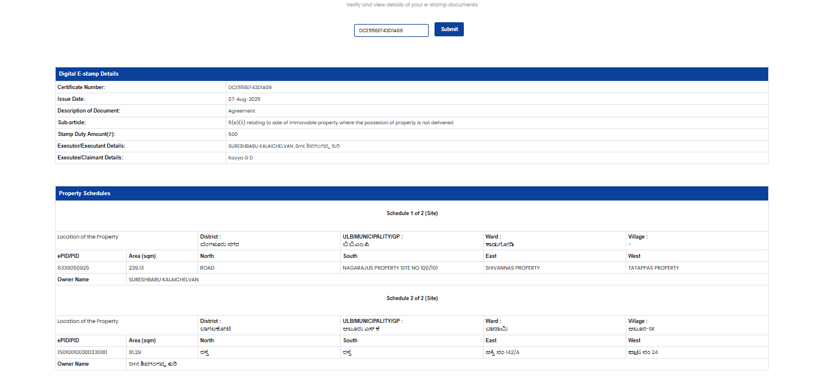
Annexure 7: Verify Document

Annexure 8: e-Stamp certificate template
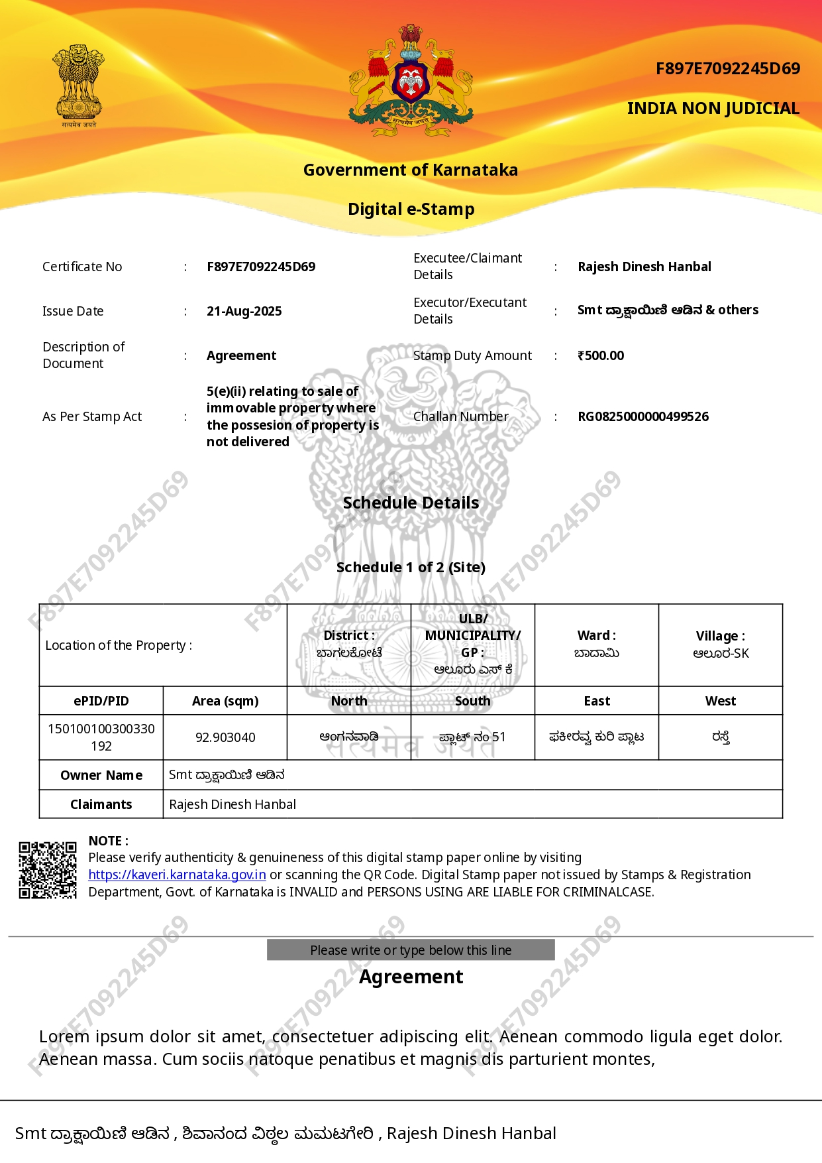

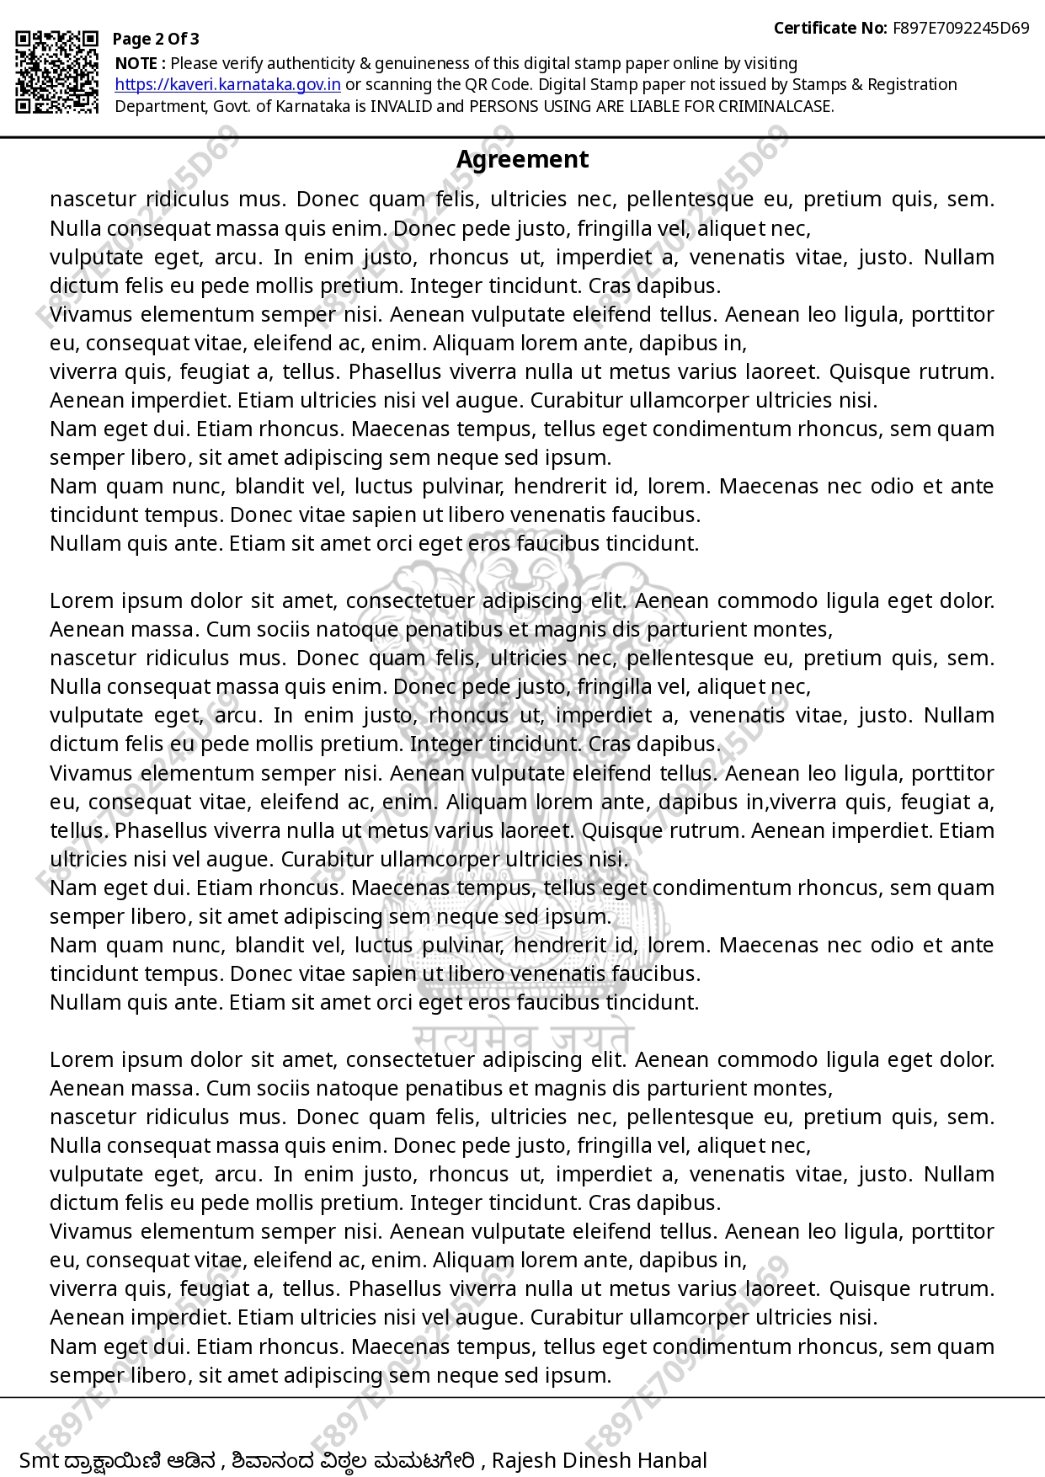

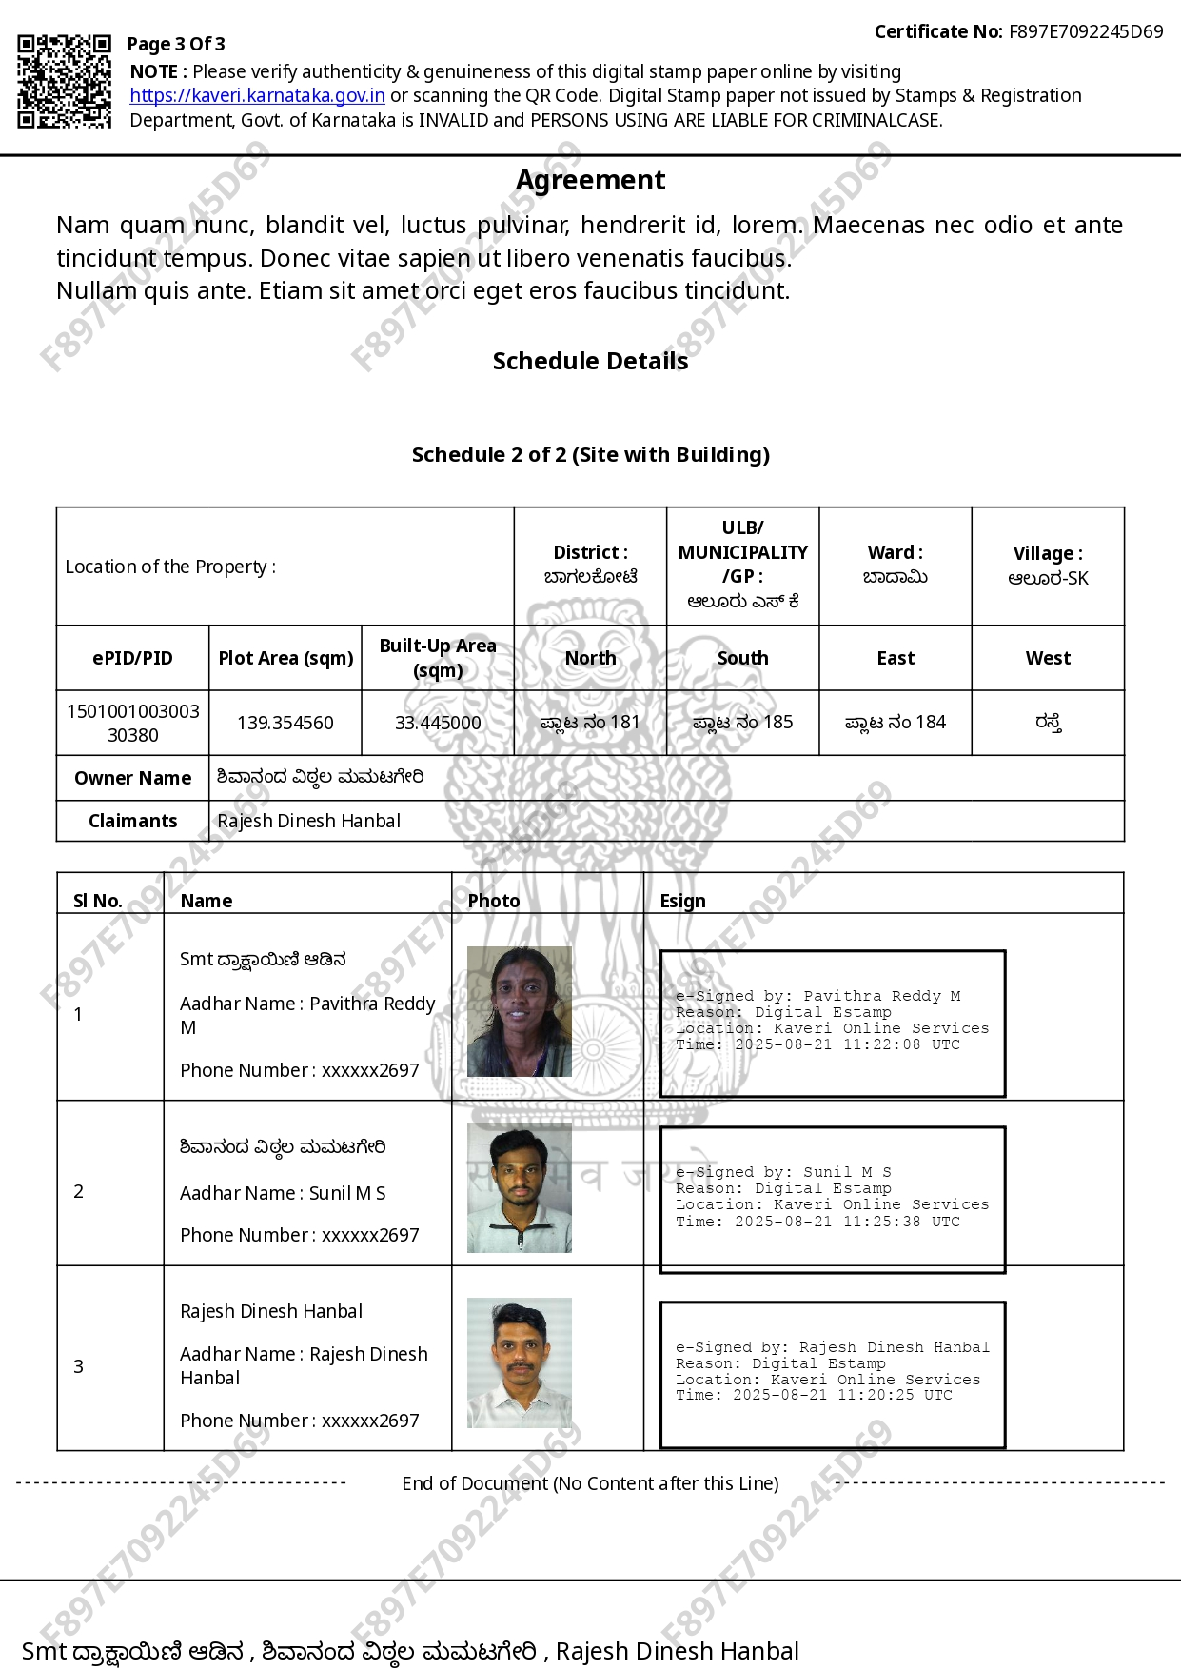

Separate note will be shared on integrating mobile based login.
Aadhaar e-sign is recognized as a valid form of electronic signature under Section 3A in conjunction with Schedule 2 of the Information Technology Act. In accordance with this legislation, users can authenticate their e-signatures through Aadhaar e-KYC using a one-time password (OTP).

